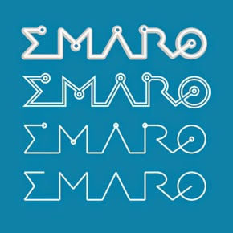

### Robotics Engineering / European Master on Advanced Robotics Plus

## Title MENTORE: a Motivational and ENTertaining Ontology-based Robotic system for Education

### Group project supervisors: Carmine T. Recchiuto, Antonio Sgorbissa

## Motivations and general objectives

The MENTORE project aims at developing an innovative robotic system for education, conceived to be a complement to the standard teachers' activity. The system will be composed of a small, low-cost robot, interfaced with a Conversational-Educational Framework for knowledge-driven verbal interaction, whose contents can be daily added by teachers.

The Conversational Framework will be based on the system developed in the context of the H2020 CARESSES project [1] [2], completed in March 2020, and focussing on designing assistive, companion robots for aged care, able to adapt to the culture of the individual of which they are taking care. During the project, a system for the implementation of natural and engaging autonomous dialogue patterns has been developed. More in detail, the framework is based on an Ontology, which encodes knowledge in the form of topics of conversation and a keyword-based algorithm for autonomous knowledge-driven conversation.

The MENTORE project will foresee the adaption of the framework mentioned above, to include school subjects, integrating the possibility for teachers to add contents to the Ontology. To this aim, a software for remotely adding classes and instances, with the final objective of letting the robot use them during verbal interaction with kids, will be developed in the project. The final system will be, therefore, able to produce a knowledge-driven verbal interaction tailored for educational purposes.

Possibly, techniques for adapting the robot's conversational style to the student's needs will be considered and implemented.

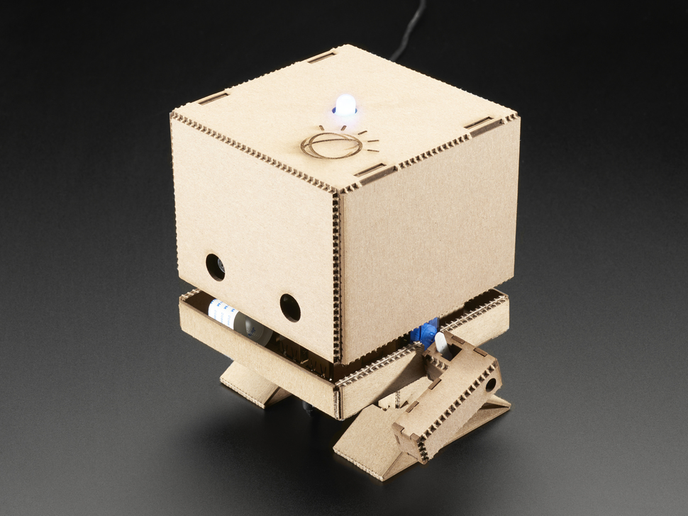Moreover, during the project, students will be required to integrate the system with a low-cost robot, the TJBot [3]. The TJBot is a simple robot, developed by IBM, which is entirely open-source. Its core is composed of a Raspberry Pi, connected to an RGB led, a microphone, a speaker, a monocular camera, and a small DC motor controlling the robot's arm. Besides its few hardware components, the whole robot can be 3D printed. However, the conversational system will also be possibly integrated with other robots (e.g., Nao [4], Pepper [5], …)

The final system (conversational framework + robot) will be used in the context of an experimental campaign carried out together with teachers and students of the Istituto Comprensivo Terralba – Scuola Media Parini-Merello, in Genoa.

## Laboratory

The project will be partly (e.g., robot assembling and testing) carried out in the Laboratorium, Building E, 2nd floor

## Proposed work plan

* TJBOT Robot assembling and integration with the existing conversational framework
* Implementation of software for the manual expansion of the Ontology, capable of defining new classes, individuals, and instances of properties.
* Analysis of the current strategies adopted for knowledge-driven conversation and possible modification to the algorithm for educational purposes.
* Integration of the new framework with TJBot, and preliminary evaluation

**Expected results**

* A novel knowledge-driven conversational-educational framework based on Ontologies
* Testing and evaluation of the low-cost robot TJBot, connected to the conversational-educational framework

**Funded projects / Companies / Other research institutions involved:** (if applicable)

The project will be carried out with the collaboration of the Director and Teachers of the Istituto Comprensivo Terralba – Scuola Media Parini-Merello

**Contacts**

Carmine Tommaso Recchiuto [carmine.recchiuto@dibris.unige.it](mailto:carmine.recchiuto@dibris.unige.it)

Antonio Sgorbissa [antonio.sgorbissa@unige.it](mailto:antonio.sgorbissa@unige.it)

**References**

[1] Recchiuto, Carmine T., and Antonio Sgorbissa. "A Feasibility Study of Culture-Aware Cloud Services for Conversational Robots." *IEEE Robotics and Automation Letters* 5.4 (2020): 6559-6566.

[2] <http://caressesrobot.org/en/>

[3] <https://www.research.ibm.com/tjbot/>

[4] <https://www.softbankrobotics.com/emea/en/nao>

[5] <https://www.softbankrobotics.com/emea/en/pepper>